* Install EC2 instance
  + **Select Ubuntu 22.04**

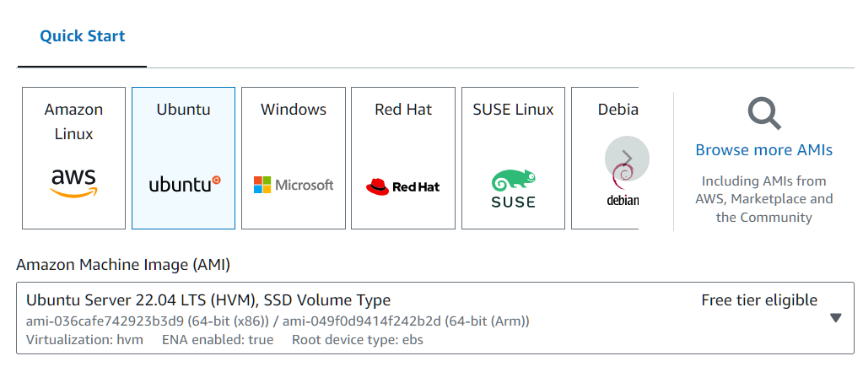

* + Create a key pair if you have not had one, download the *.pem key (make sure you remember where you put it) Note the screenshot shows dsci2024 but you can use any other name you want.

* 10-20GB is sufficient (minimum is 8GB)

* Click Launch instance!
* Select your instance, and go to Connect. Find tab for SSH client:
* Copy the Example command
* Open a terminal with access to the ssh client program
  + If you have Windows OS, install Cygwin (see note at the end)
  + If you have Mac, just open a terminal windows which already has access to ssh
* “cd” to the place where you have downloaded the *.pem key.
  + Execute: chmod 400 <your pem key>
  + (see the AWS screenshot)
* Paste the command you copied. The command looks like this:
  + ssh -i <your pem key> [ubuntu@ec2-xxxxx.us-west-2.compute.amazonaws.com](mailto:ubuntu@ec2-xxxxx.us-west-2.compute.amazonaws.com)
    - again, see the screenshot for example
  + say yes to the question.
  + You should now be connected to EC2.

* + Note: when you restart the instance, its ip address changes. You need to recopy the ssh connection string from EC2 web site.
  + Text editor on EC2:
    - nano
    - vi
* Before installing the following software, please first update package database by executing:
  + sudo apt update
* Install Java SDK:
  + sudo apt install default-jdk
* Install Spark:
  + (note: please install Spark, you need to install Java SDK first, see previous step)
  + wget <https://dlcdn.apache.org/spark/spark-3.5.2/spark-3.5.2-bin-hadoop3.tgz>
  + tar xvf spark-3.5.2-bin-hadoop3.tgz
  + pypsark (if you have set up .bashrc to include spark's bin directory in path) or go to spark installation directory and execute: bin/pyspark.
* Install MySQL:
  + sudo apt install mysql-server
  + sudo mysql
  + In MySQL prompt (mysql>):
    - (note: do not copy and paste the following command, since it might add a new line character after ‘-‘.)
    - alter user 'root'@'localhost' identified with mysql_native_password by 'Dsci-551';
    - exit
  + mysql -u root -p
    - on password prompt, type: Dsci-551 and hit enter
  + (note) MySQL server consumes a lot of main memory
    - Step the server first, please you run other program, e.g., hdfs, spark, …
    - Stop the server by executing:
      * sudo service mysql stop
    - You may start the server by executing:
      * sudo service mysql start
* Install Hadoop:
  + wget <https://dlcdn.apache.org/hadoop/common/hadoop-3.4.0/hadoop-3.4.0.tar.gz>
  + tar xvf hadoop-3.4.0.tar.gz
  + **(Skip this step if you are taking 351):** Follow the instructions in: <https://hadoop.apache.org/docs/stable/hadoop-project-dist/hadoop-common/SingleCluster.html> on “pseudo distributed operation”. In particular,
    - Follow the configuration steps
    - Follow the “set up passphraseless ssh” steps
    - Edit the file: :~/hadoop-3.4.0/etc/hadoop/hadoop-env.sh
      * add the following line (you can edit line 54):
      * export JAVA_HOME=/usr/lib/jvm/default-java
    - follow the execution steps to format namenode, start dfs, etc.
  + note (**ignore this if you are 351 students**):
    - if namenode does not start, try to reformat the namenode
    - if datanode does not come up, try:
      * rm -rf /tmp/hadoop-ubuntu/dfs/data
        + (note) this will remove the directory where hdfs stores its data node content.
      * Restart the dfs
* Install MongoDB:
  + Follow the instructions in <https://www.mongodb.com/docs/manual/tutorial/install-mongodb-on-ubuntu/>
  + Make sure using the steps for Ubuntu 22.04
  + To start server: sudo service mongod start
  + Run client: mongosh
* Install pip:
  + sudo apt install python3-pip
* Windows OS: If you are using Windows, please first download & install Cygwin.
  + If you want to use Cygwin
    - Please go to Cygwin.com
    - Download and execute setup-x86_64.exe
    - Make sure you select openssh package when installing
    - Your Cygwin default installation directory will be “c:\cygwin64”
      * Note: your home directory will be in msy2 will be like:
        + c:\cygwin64\home\<your user id>
      * copy your *.pem file downloaded from AWS to this directory